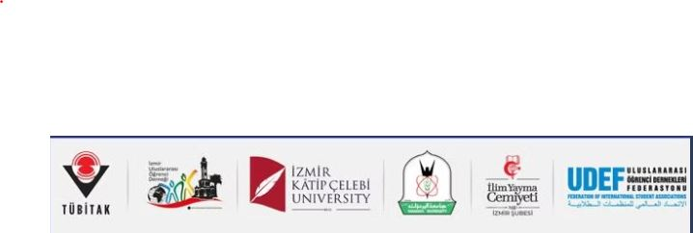

International Students Social Sciences Congress IV
October 23-24, 2025

ABSTRACT EVALUATION FORM
Abstract No:
Title of the Abstract:
Evaluation Criteria | Adequate | Partially Adequate | Inadequate
Is the subject and content of the abstract relevant to the main theme of the congress?
Is the title of the abstract to its content?
Does the abstract cover the aim of the study, the findings obtained according to the applied method, and the recommendations?
Are the keywords sufficient and appropriate?
Is the subject and aim of the study sufficiently emphasized in the introduction section?
Are the research method(s) used appropriate for the subject of the study?
Are the research findings accurately explained according to the method(s) followed?
Is the language of the study sufficiently clear and comprehensible?
Does the study have originality and scientific contribution?
Has the abstract been prepared in accordance with the writing rules specified on the congress website?

Evaluation Result
The abstract can be published in its current form.
The abstract can be published after the corrections are checked by the editor.
I would like to review the abstract again after the corrections are made.
The abstract is not suitable for publication.

ADDITIONAL COMMENTS
In addition to the evaluation stated above, please indicate in this section the issues you would like to be corrected in the abstract and your suggestions.

SCORING
Please evaluate the abstract by taking all criteria into consideration and give a score out of 100. Write your score in the box below.

Reviewer Information

Title / Name Surname
Adress
E-mail
Phone
Date
Signature

